2016 / CS /023

A.H.V Darshana

**NSBM** Course Enrollment system

This is the documentation about the Course Enrollment System for NSBM Green University Town. In this project I use the **JAVA Programming language** with **Java Swing GUI** library & PhpMyAdmin **MySQL** as the Database Platform. I used the NetBeans IDE for develop the system & use the NetBeans’ **jdbc** database service for connect java with MySQL.

Now, I explain about my scope of the system. I assume that software has an only One user who are the admin of the system. All the details of Students, Lecturers & Others are handled by Admin.

I added few menus in Home as **Bachelor** **Students, Master Students, Subjects, Lecturers, Timetable, Labs** and **About**.

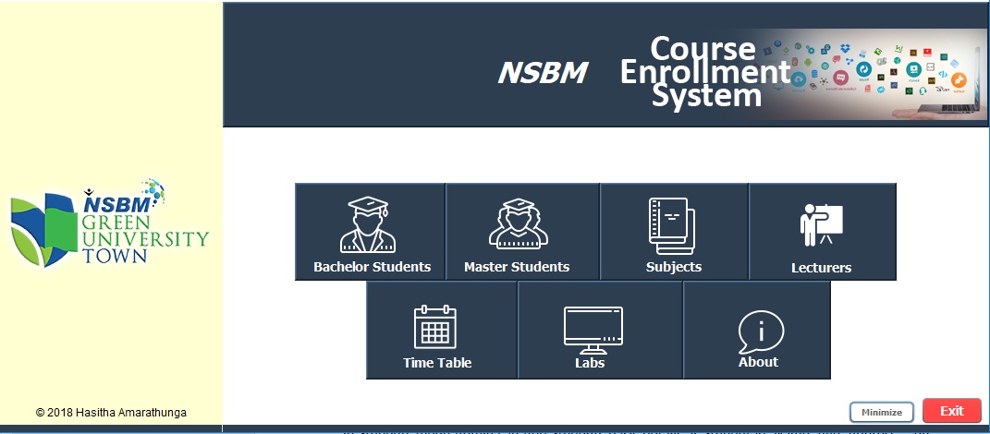

In Both Bachelor & Master Students menu include **Add Details**, **View** ,**Update** & **Delete** , **Add Subjects**, **Edit Subjects**, **Add Marks**, **View Grade & View Year Final Report** menu’s.

In that each menu’s has select the faculty, course, Year and semester etc. for manipulate data.

Following show, you the interface of Bachelor Students menu that same as Master Students. So I will explain only the Bachelor Students menu.

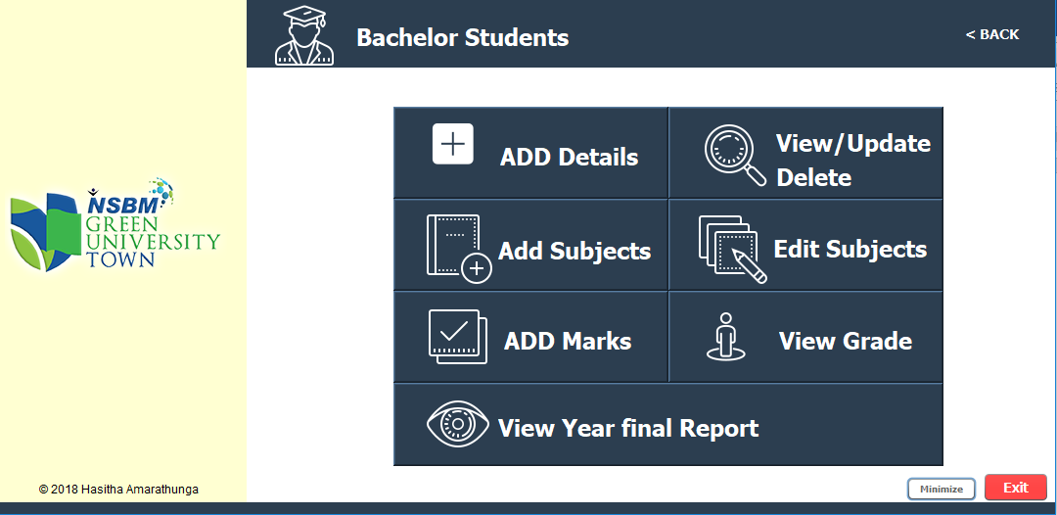(This is the interface of Bachelor Students menu)

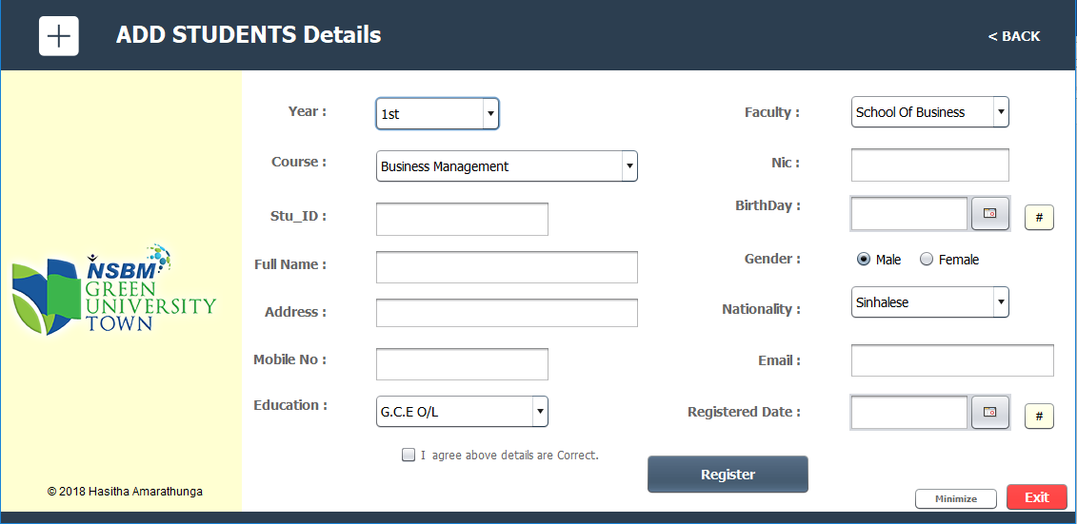In this Interface, now I will explain about **Add Details Menu**.

In this Interface, First Admin will select the year , Faculty & course & give a **Student id** & all the other details are compulsory and fill all the details and finally tick the agree and Register. In the back-end all the details admin filled are gone to **students** table of **nsbm** database in phpMyAdmin.

In this fields if NIC is included then Birthday can **auto-generated** clicking the **#** button near the birthday field.

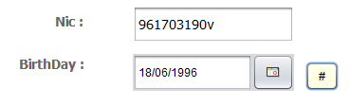

And also system can auto generate the registered date clicking the # button near the registered date.

every window has a back, Minimize and exit buttons. In back button admin can go to previous window. Ok let’s got to previous.

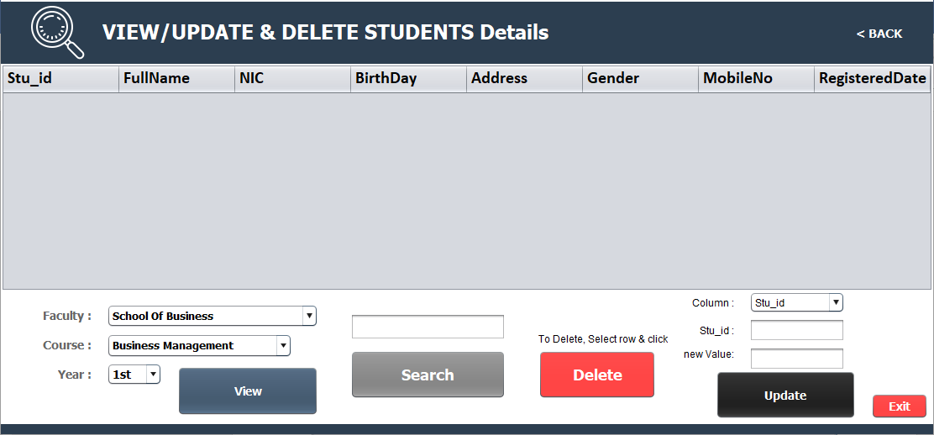Now I will explain about **View/update & Delete Menu**

In this Interface Admin can View the all the details of each faculty, each course, each year in one time. And also can filter the details in search text field that filter the first Name & Last Name.

And also Admin can delete a field clicking the field and using Delete button. For update any details first select the column name, Stu_Id (Stu_Id also can be click in table, then it auto filled the Stu_Id field.) and enter new value to update and click Update.

**Following show the interfaces of View , Delete & Update.**

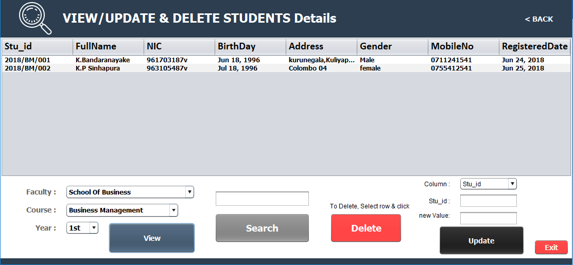

Above interface show the all the details of business Management 1st year students.

Below interface will see you about how update details.

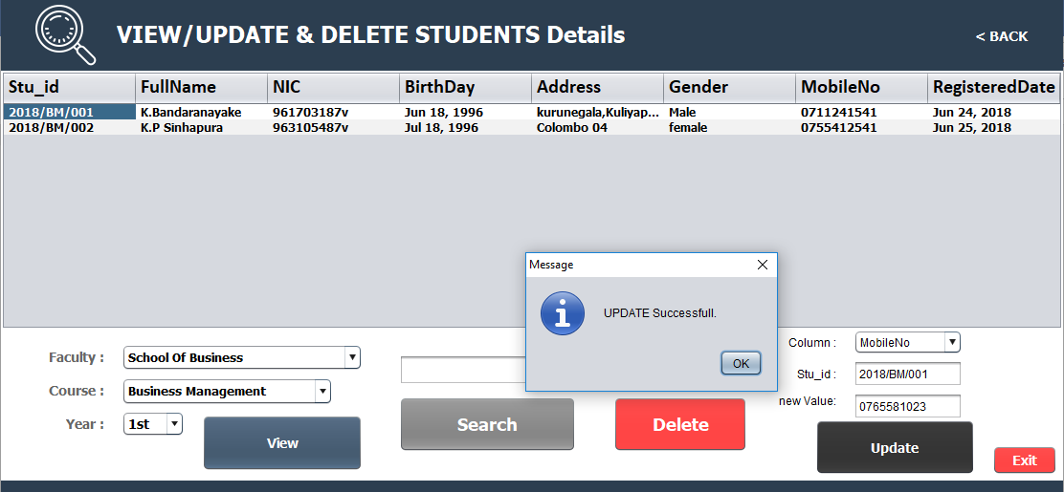

To **update** details Admin must select column that is needed to update and input the student id and new value for update & click the button.

Following show the deletion.

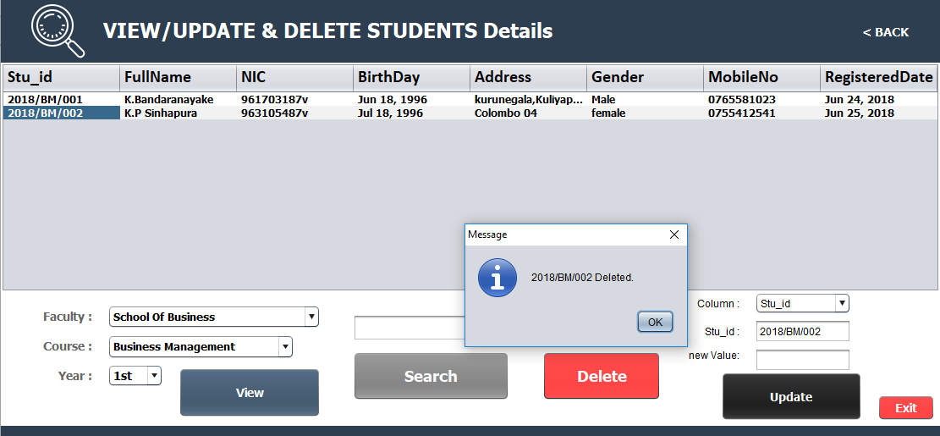

Admin can **delete** some details as click some cell and click the delete button.

Now let’s go to **Add Subjects Menu**

In this menu select the year, semester, Faculty & Course and Enter the Stu_Id for add Subjects. Next you can see first two subjects cannot select because these are compulsory subjects. So you can see the Subject name for each subject code in Right side of the interface. After select next two subjects tick the agree and click **Add Subjects.**

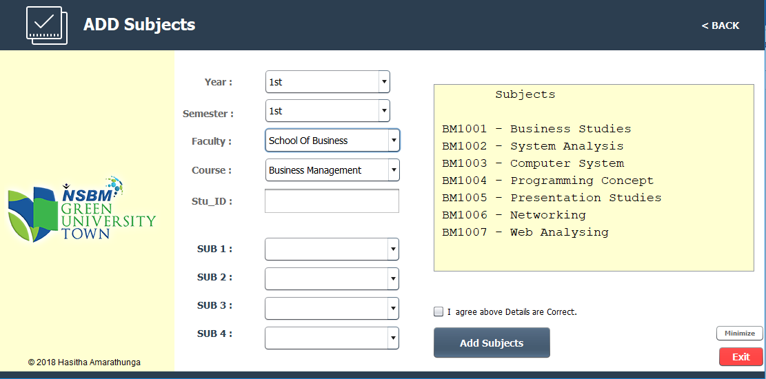

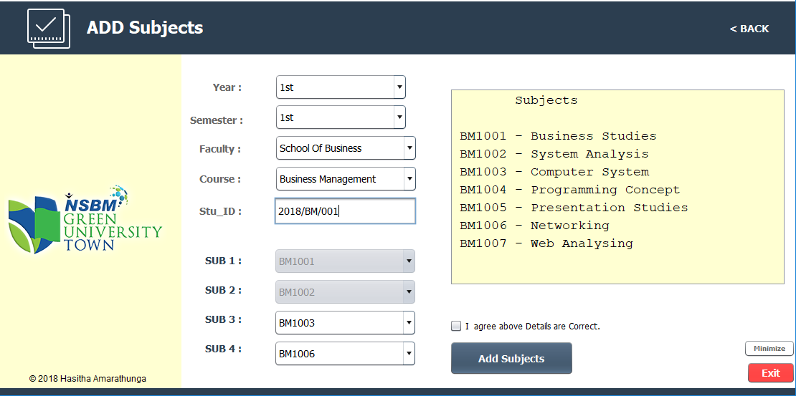

This interface automatically loaded when basic students details added and if it is Successfully registered. But you can add manually using that menu.

Next go to Edit Subjects menu to Edit the subjects you selected. It is only work for registered and subjects added students. It’s show the subjects for 3rd and 4th subjects. After select sub3 & sub4 Click save edit.

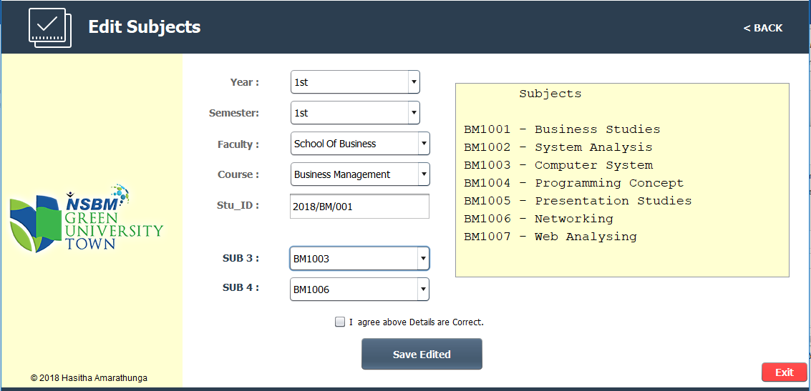

Let’s go to **Add Marks Menu**

After selected year, semester, faculty & course and enter the Stu_Id you can select the Subject that registered and enter the marks for that subject and click Add Marks.

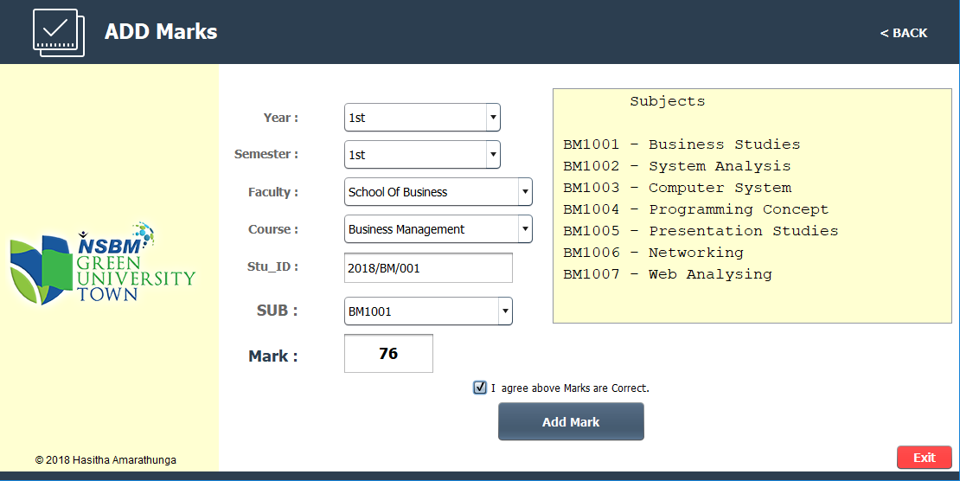

In this menu if Stu_id is not valid then not show the Subjects.

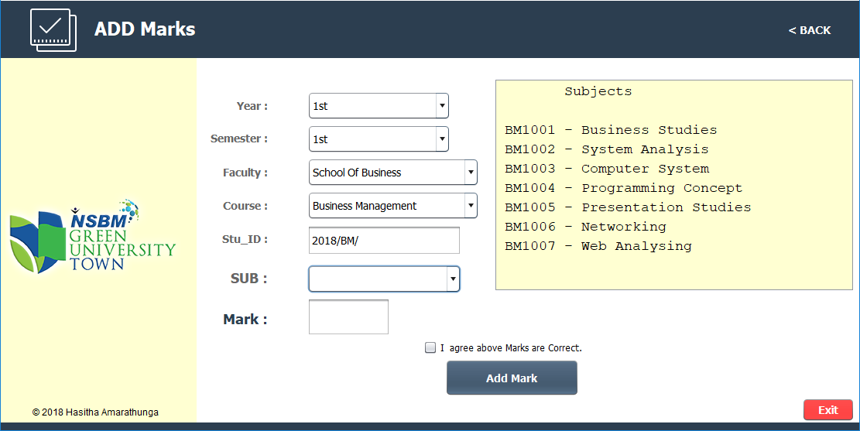

Let’s go to **View Grade** Menu.

In the menu You can select year, semester, faculty, course and enter the Stu_Id. If it’s not valid not show any subjects.

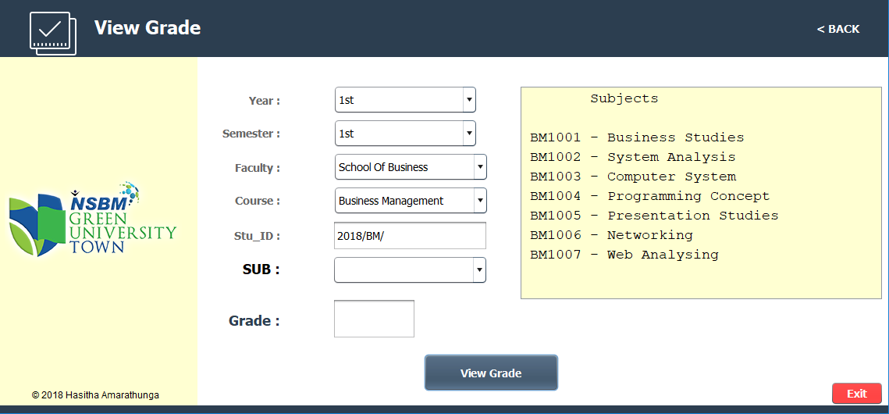

If it’s Valid It’s show that student subjects and you can see the grade if it’s included marks.

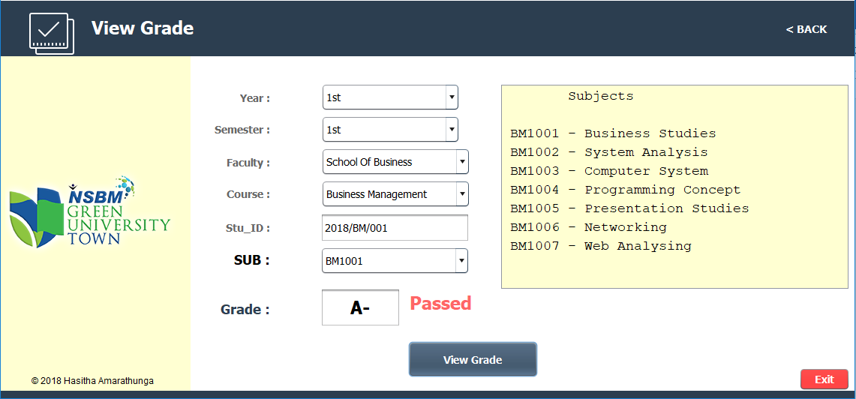

Let’s go to **Year Final report** menu.

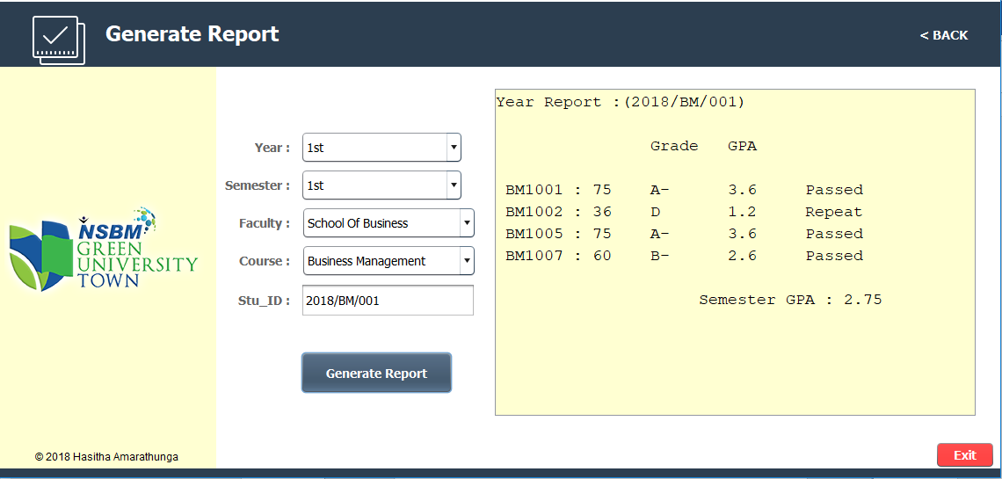In this menu Admin can create the report of Any students. It show the Subjects & marks Grade , GPA of each Subject , if the subject is passed or repeat & the final GPA of each Semester.

These are the main things of **Students Menu**

Let’s Back to the **Home**

Now Discuss About **Lecturer Menu**

In lecturer menu has three sub menus that are Add Details, View/Update & Delete Details and Add lecturers to Subjects Menu’s.

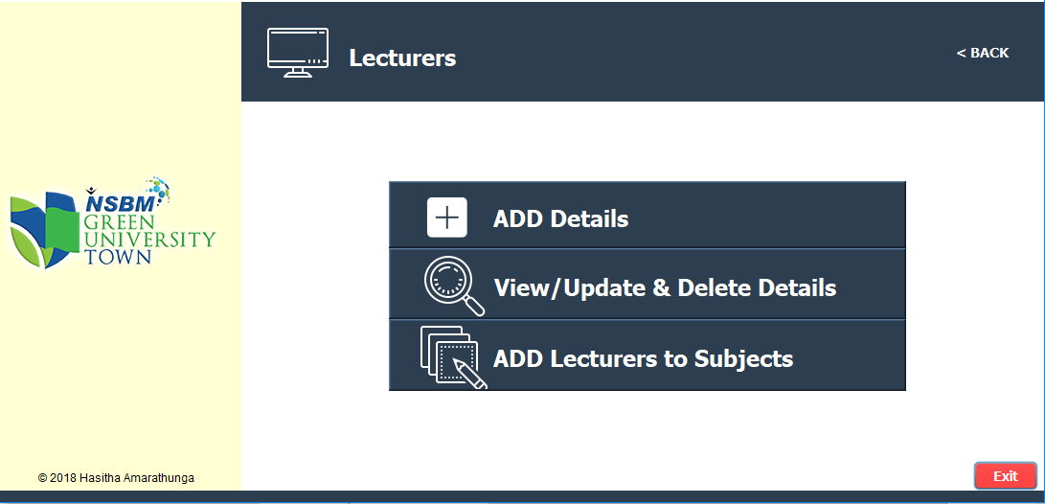

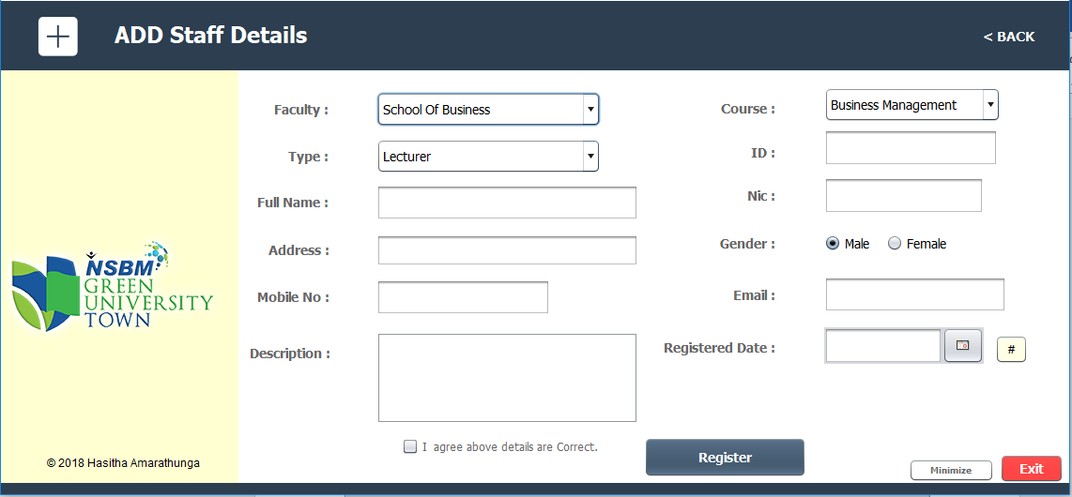Like Students’ menu Admin can add Lecturers & Instructors basic details in Add details Menu.

Admin can select the type as Lecturer & Instructor. Then ID will auto generated.

In description Text are admin can describe More details about Lecturer like about Degree, experiences etc. Finally filling all the details and Admin can click Register button to Add details to the database.

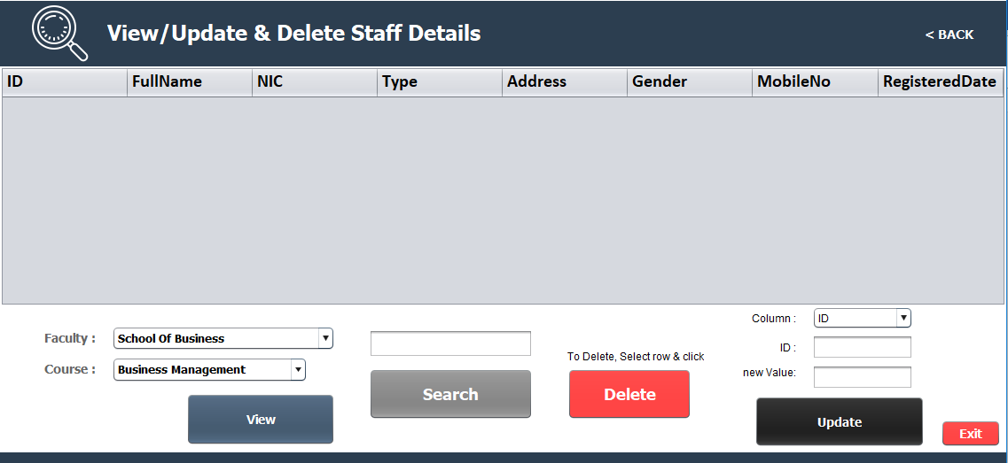After Registration back to Lecturers menu and go to view Menu & Admin can see the all details about Lecturer and Admin can search , update & Delete any details.

In this menu work same as Students view Menu. So I don’t describe about each View delete Search and Update again.

**Let’s go to Add Lecturers to Subjects.**

After select Faculty, Course, Year & Semester and Enter the Lecturer or Instructor Id Select the subject and click Add Subject.

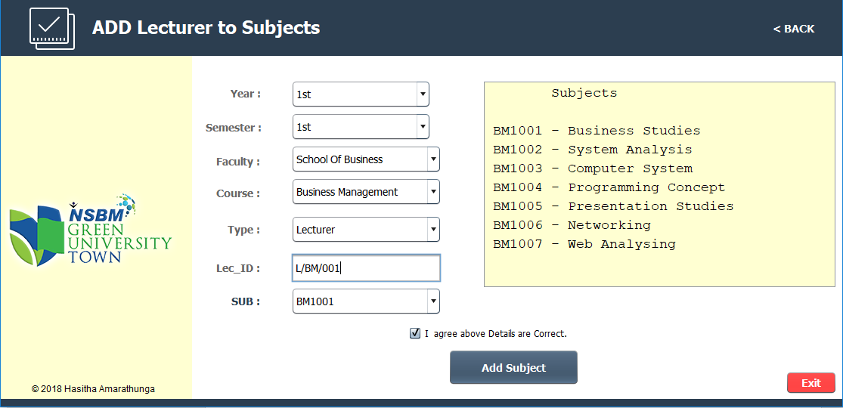

These are the main things of Lecturer Menu.

Let’s go back to Main Menu.

Now I will discuss about **Subjects** menu in Home.

That menu show the details about the lecturer of each faculty each course each subject.

It’s show the subject details in right corner of the interface and under that field show the details of lecturer Name, Type, Email & description about that lecturer.

Following show the details about Business management subject BM1001.

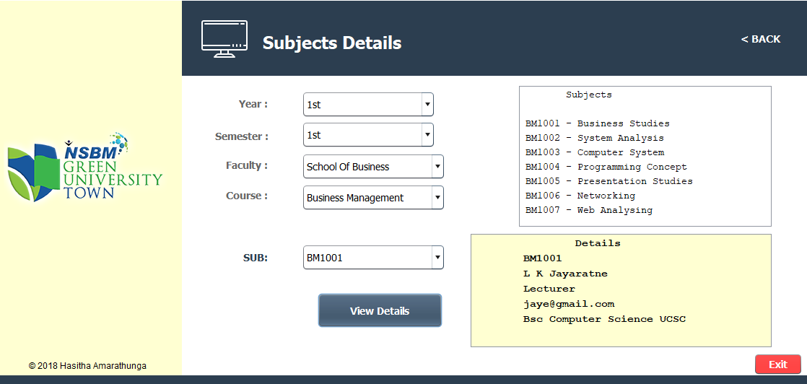

This is the main purpose of the **Subjects** menu.

Let’s go back the Home.

Let’s go to **Time Table** Menu.

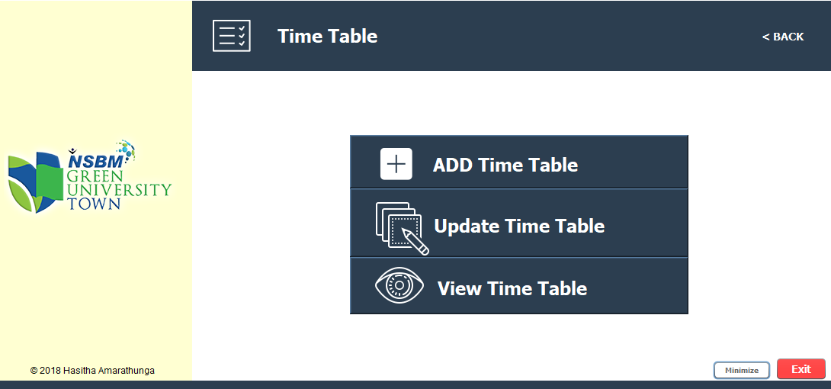 Following show the sub menus of Time Table Menu.

Let’s go to Add Time table menu.

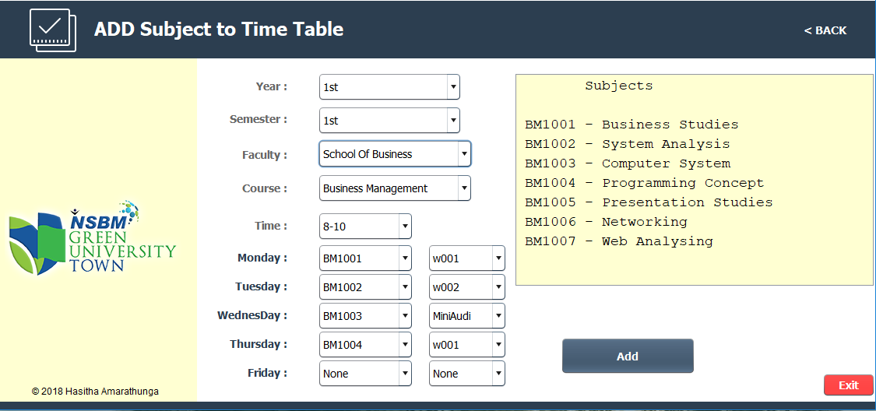In Add Time table menu can Add Time table newly. That’s mean if admin add the subject for particular course in very first time.

In this first select the year, Semester, Faculty, Course and Time period. After selected that you can select subject & hall for particular day. For example you want to add Business management course 8-10 time Monday to BM1001 & hall w001 You select that from the fields.

Above added every week days 8-10 time period time table of Business Management course.

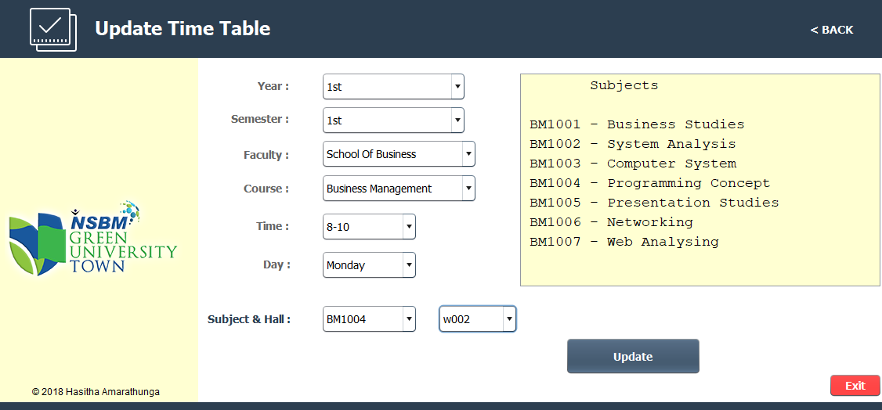**Next let’s go to Update subject Menu.**

If you added some subject to particular time period but you want to edit the Subject of that particular date and day then admin can help that menu.

For an example You want to change in the business management time table **Monday 8-10** as **BM1004** and hall as **w002** you can select as above scenario and Update.

**Let’s go to View Time Table.**

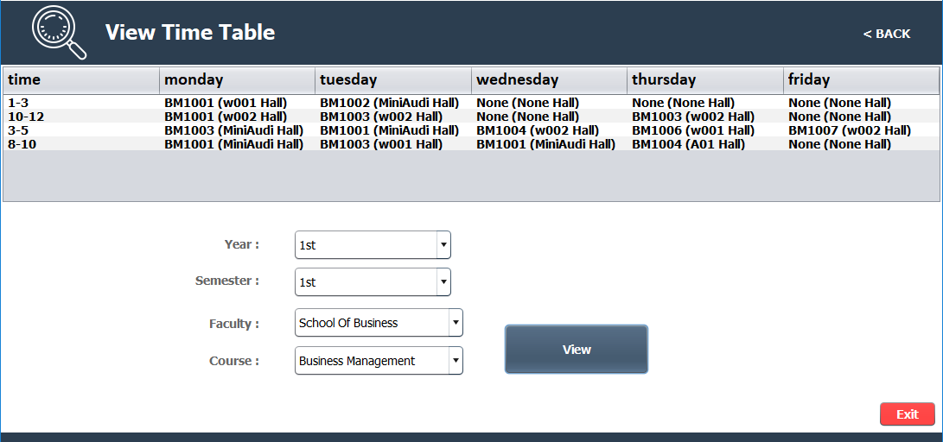You can select Faculty, Course, Year & semester and Show the time table as below.

These are the features of Time Table menu.

Let’s go back to Home page.

Let’s discuss about **Labs** Menu.

Labs Menu show the schedule of Labs. It will filter the Faculty, Subject & day. That’s mean if you want to see Faculty of Management, Business Management Monday Lab schedule, you can select that field and View the Labs Schedule.

Following show the interface of that.

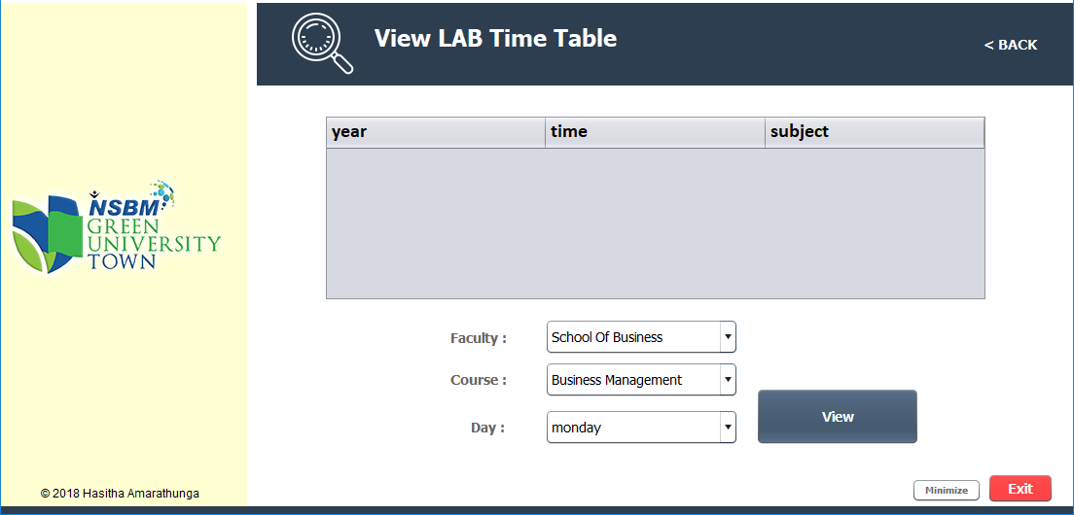

(Before View)

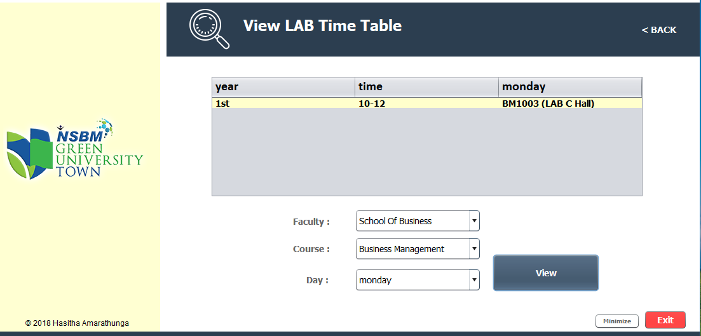Following show the after clicking View Button.

So, these are the main features of that course Enrollment System.

* A.H.V Darshana -